**INTERNET of THINGS**

**Lab 1 Assignment**

**On**

**MQTT, Docker and, Arduino Simulator**



**Manthri Bala Kiran**

[**H19baman@du.se**](mailto:H19baman@du.se)

Task 1 & 2:

Fig: 1: Publishing the messages to the subscriber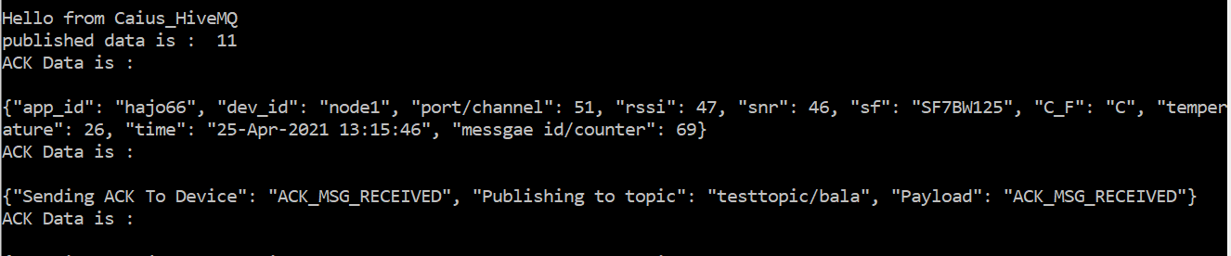

Fig 2: Subscriber and publisher

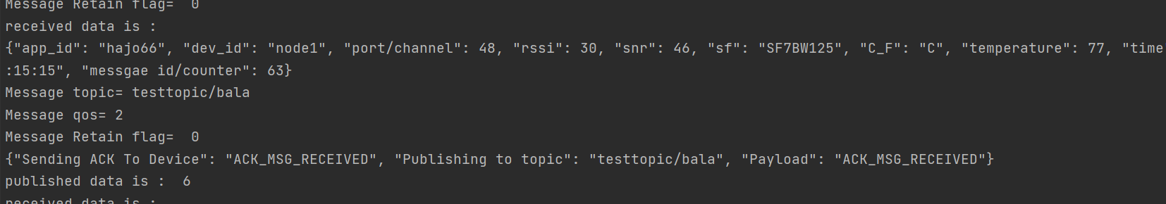

Task 3:

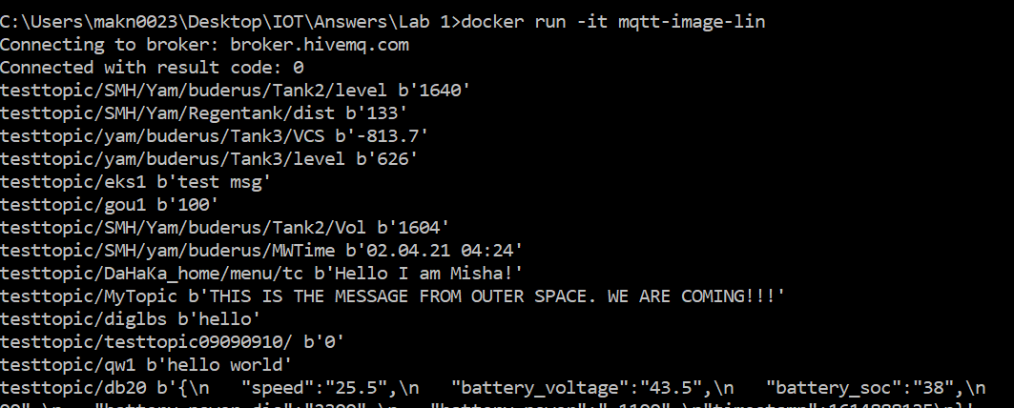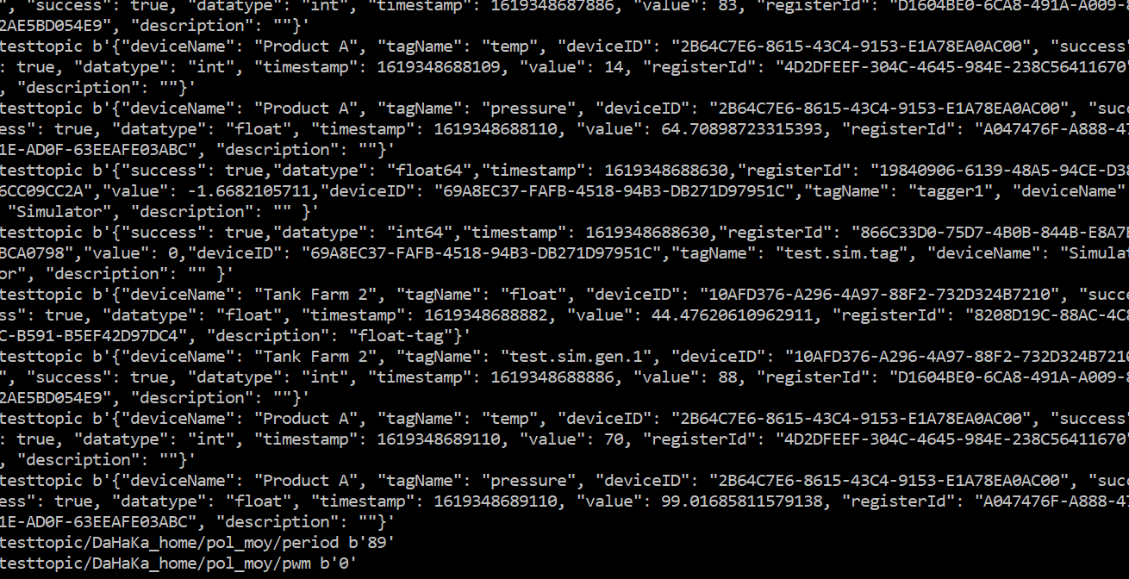

Feedback:

1. The lab material was very relevant but for me, it took some time in understanding the concept explained in the lab manual. But still, I was unclear about some things and I need to figure them out and understand them.
2. I suggest no corrections.